Task1

Overdamped :

|  |  |
| --- | --- |
| Vpp | 2.3732 V |
| Max | 2.3626 V |
| Min | -10.63647 mV |

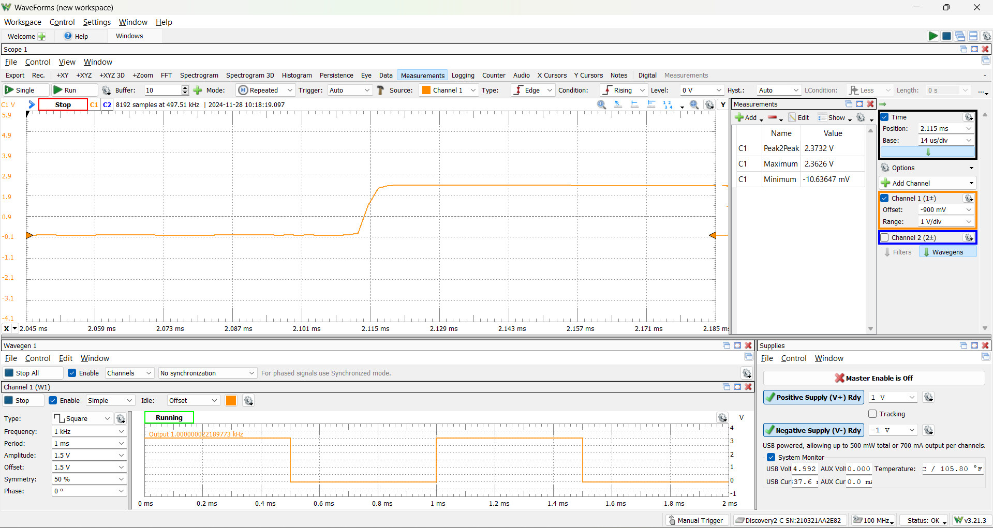

Underdamped :

|  |  |
| --- | --- |
| Peak2Peak | 4.6987 V |
| Maximum | 4.6478 V |
| Minimum | -50.96325 mV |

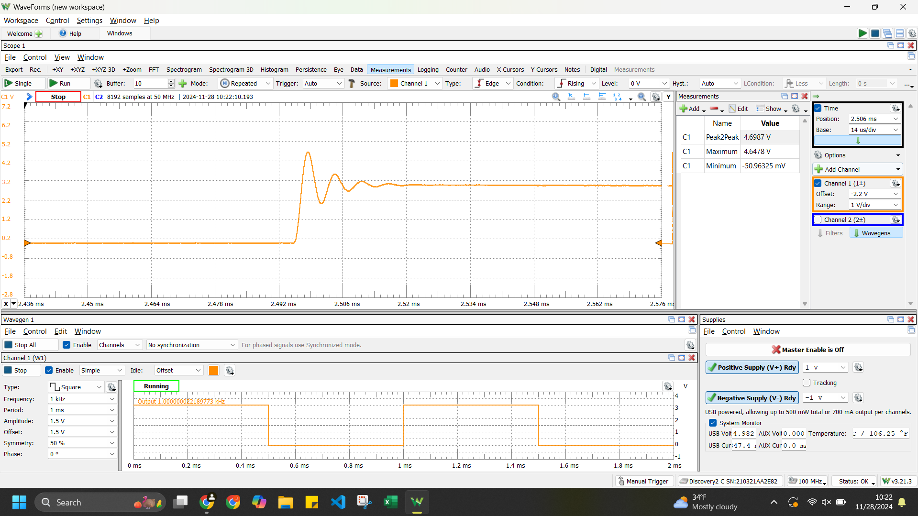

Question4:

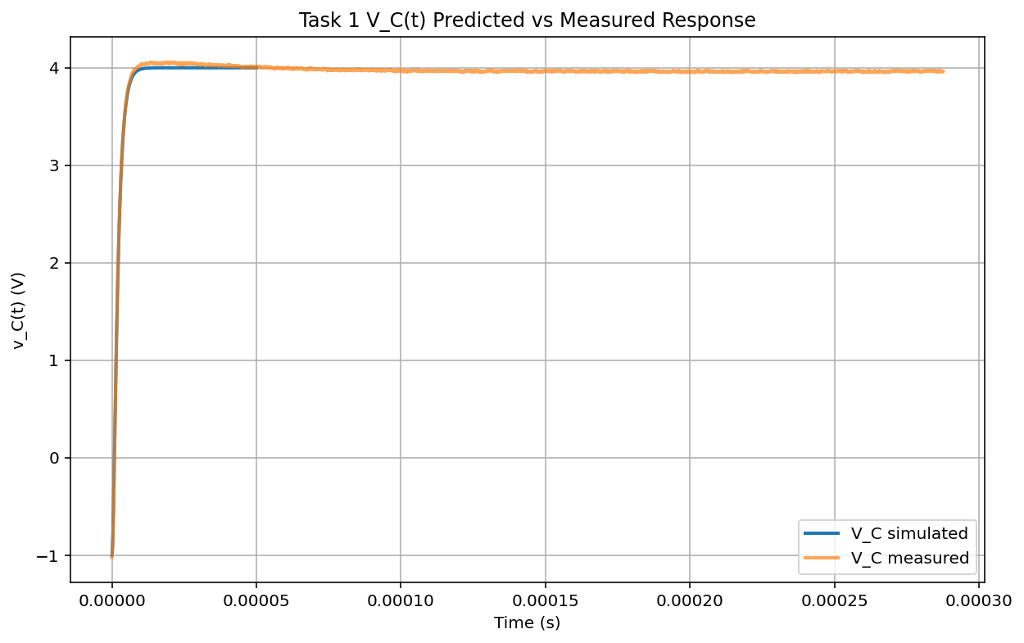

Task 2

Overdamped:

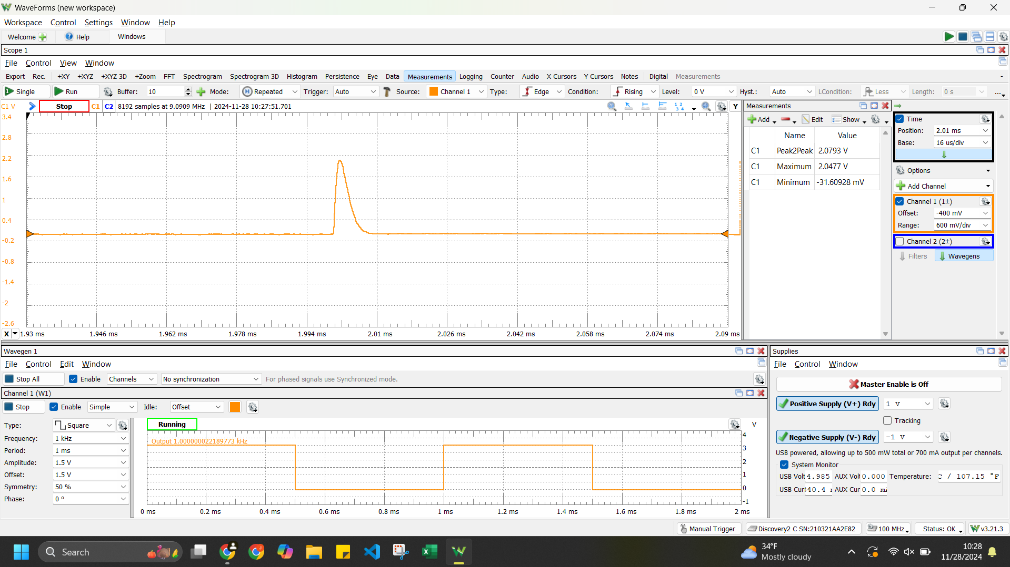

|  |  |
| --- | --- |
| Peak to Peak | 2.0793 V |
| Maximum | 2.0477 V |
| Minimum | -31.60928 mV |

Underdamped

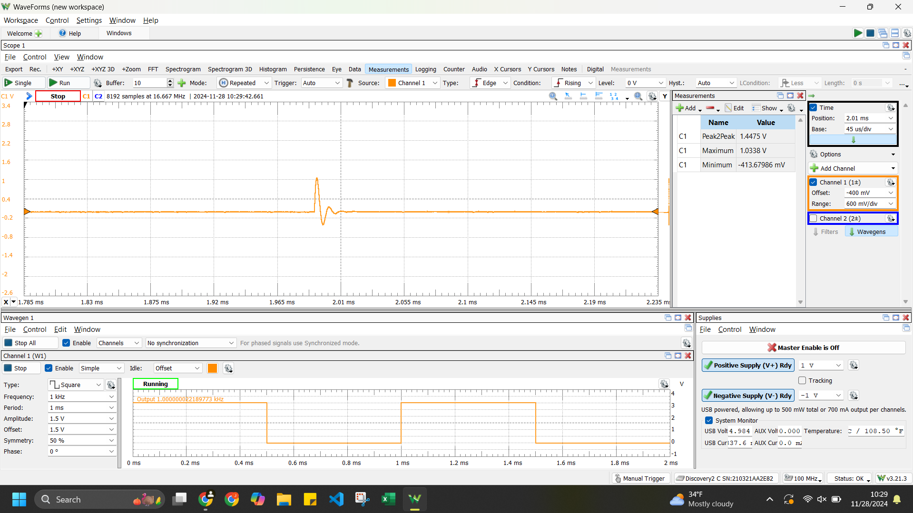

|  |  |
| --- | --- |
| Peak to Peak | 1.4475 V |
| Maximum | 1.0338 V |
| Minimum | -413.67986 mV |

Question4: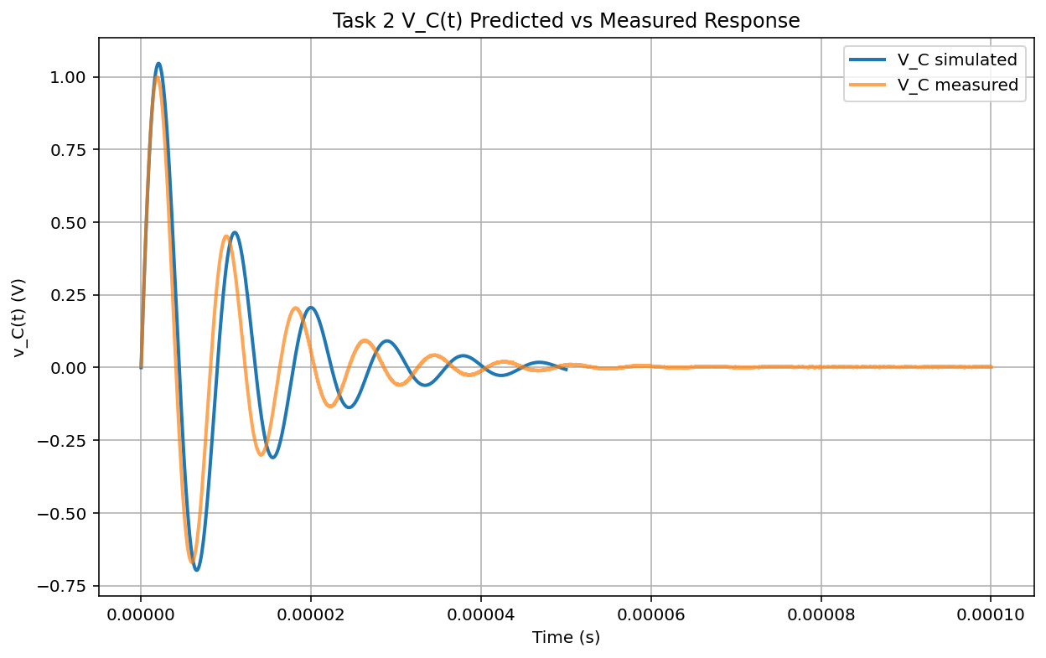

Task 3

ESR of Inductor (idk what values are needed so i took a bunch of screenshots)

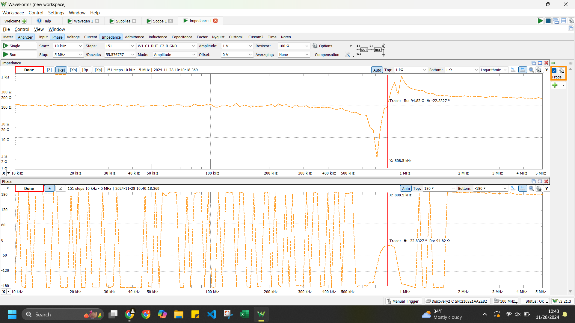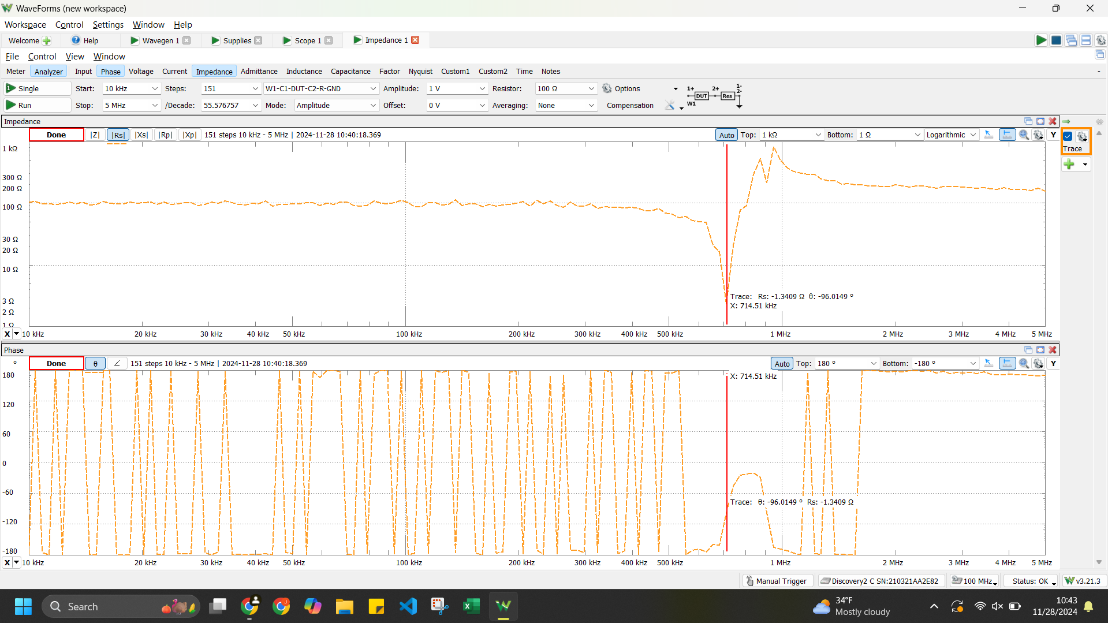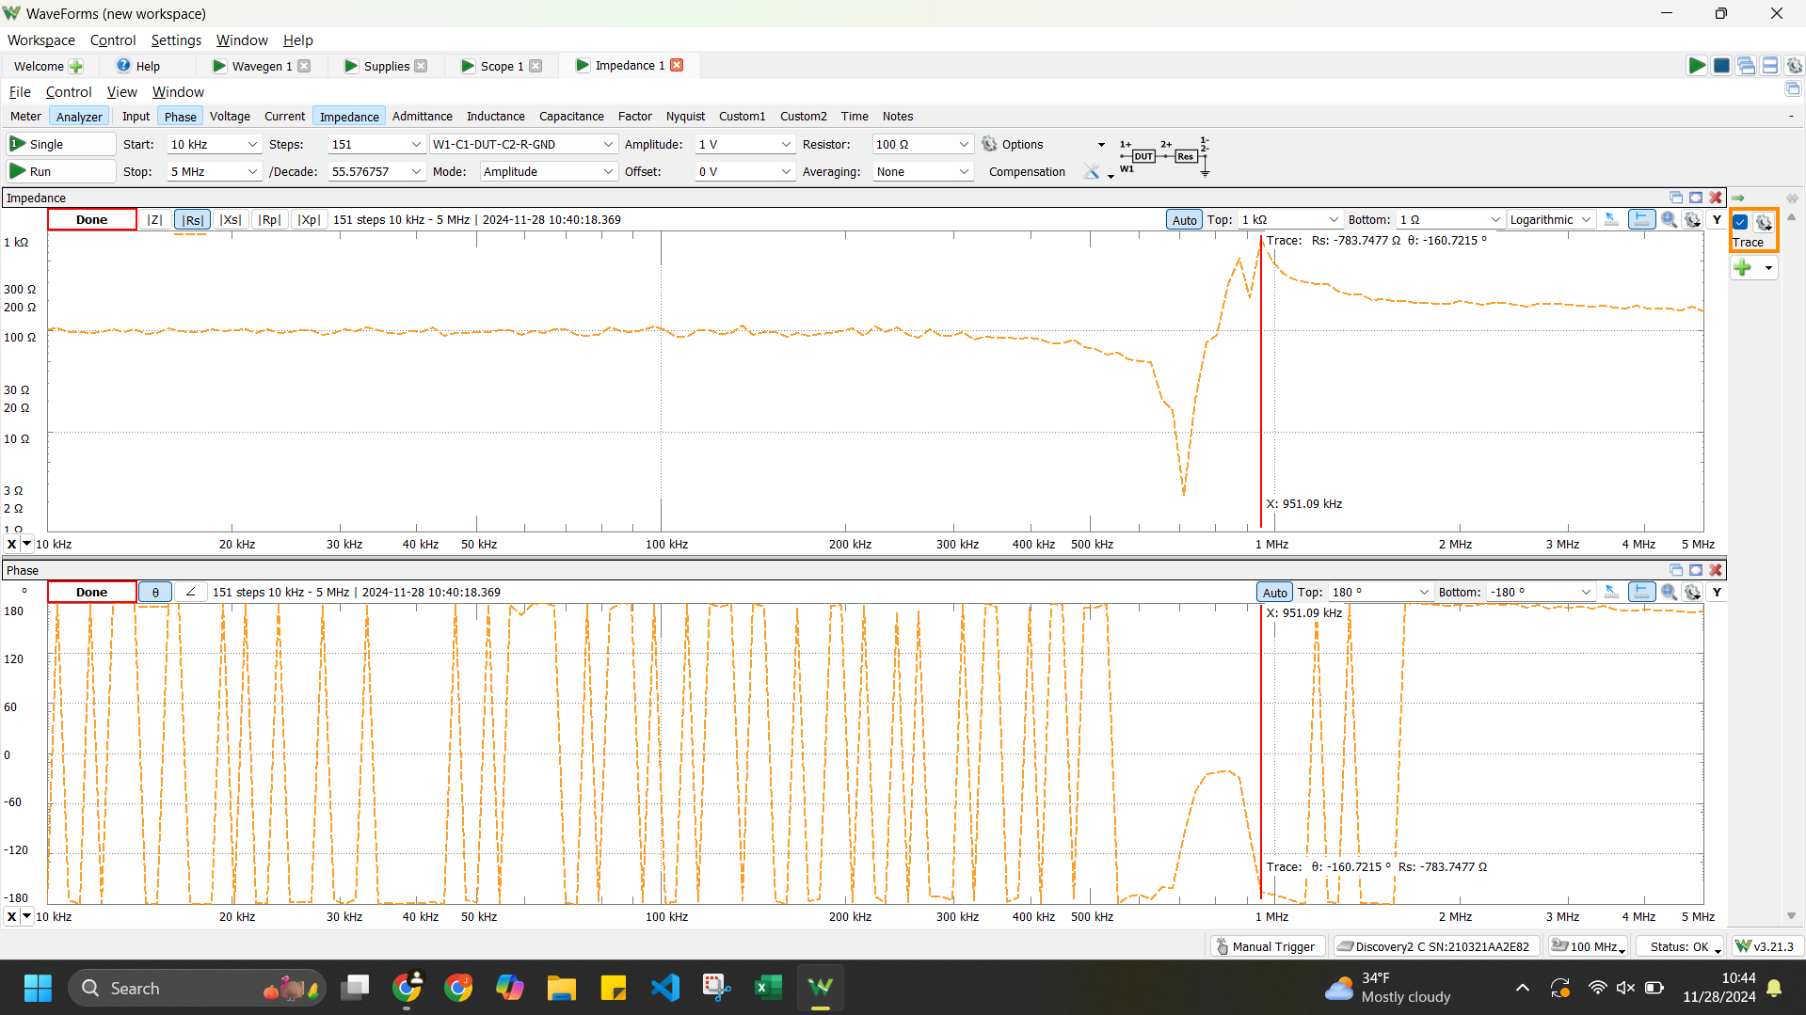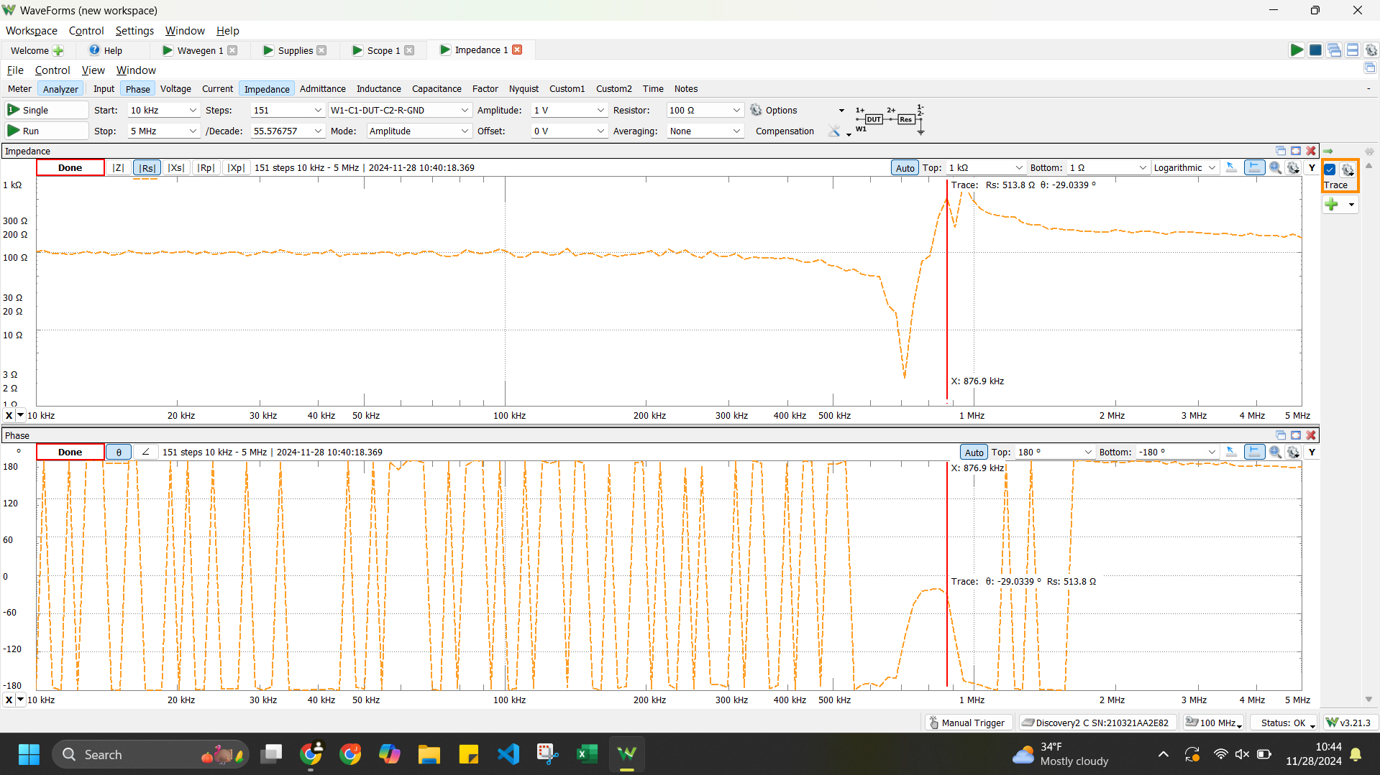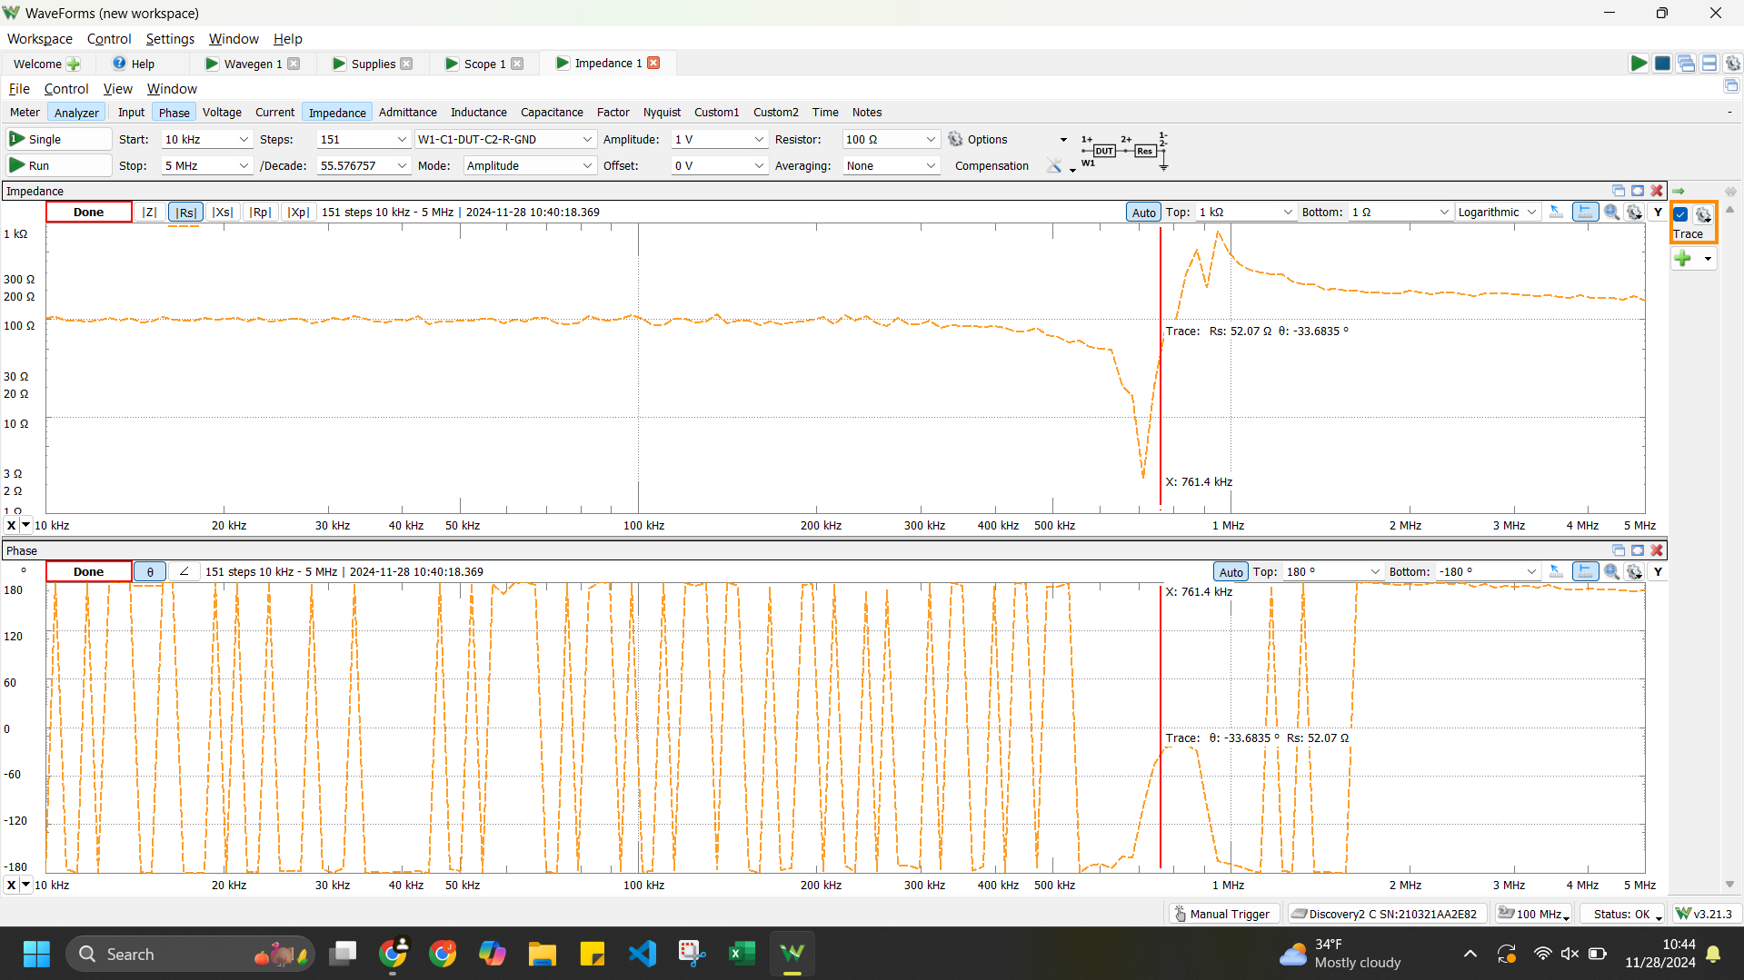

Just use 2.1 ohms for the inductor shit

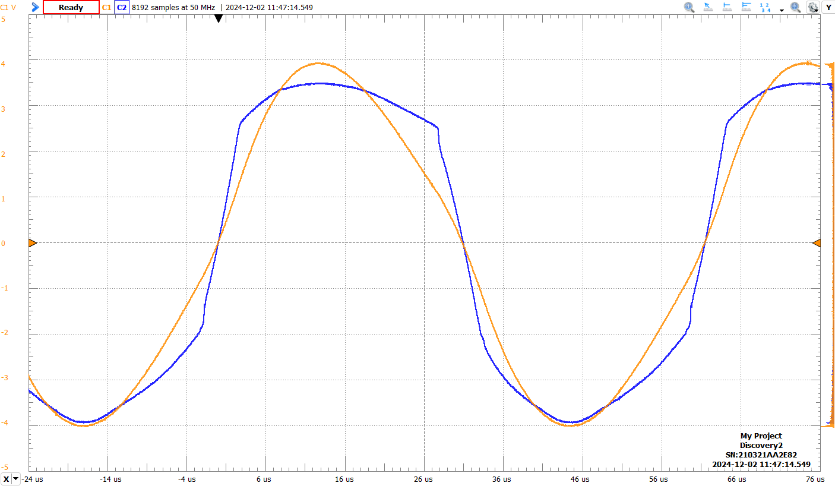

|  |  |  |
| --- | --- | --- |
| C1 | Peak2Peak | 7.9794 V |
| C1 | Frequency | 16.275 kHz |
| C1 | PosDuty | 50.49% |
| C1 | Average | -297.78767 mV |
| C1 | Period | 61.445 us |

|  |  |  |
| --- | --- | --- |
| C2 | Peak2Peak | 7.4364 V |
| C2 | Frequency | 16.267 kHz |
| C2 | PosDuty | 51.14% |
| C2 | Average | -348.23859 mV |
| C2 | Period | 61.474 us |

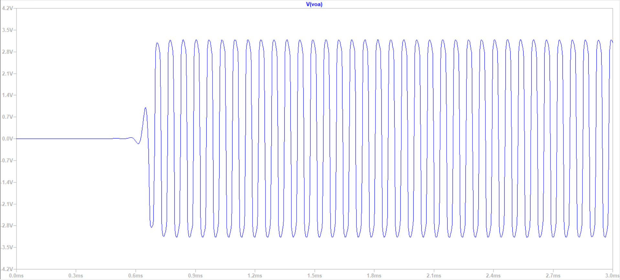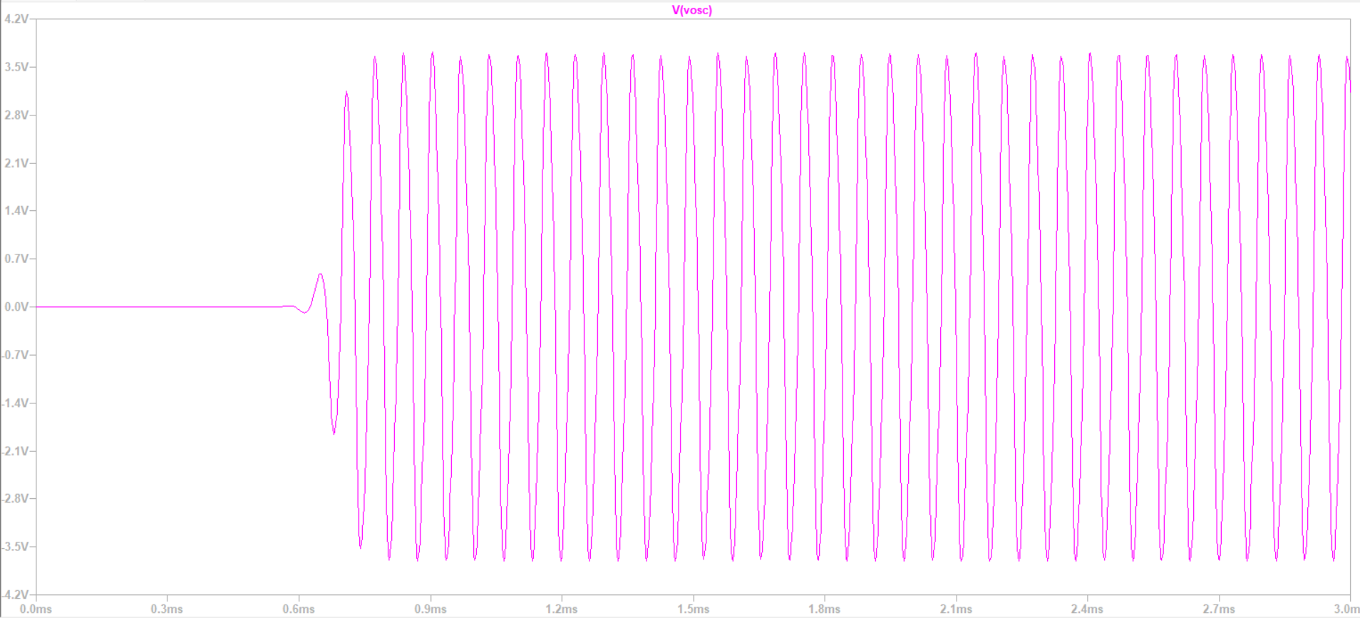

Simulated frequency is around 15.3 kHz for Voa and Vosc